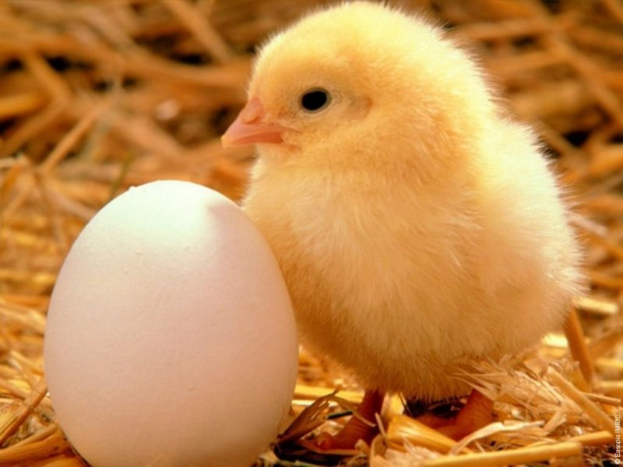

|  |  |  |  |  |  |  |  |
| --- | --- | --- | --- | --- | --- | --- | --- |
| **K** | **U** | **R** | **I** | **A** | **T** | **K** | **O** |
|  |  |  |  |  |  |  |  |

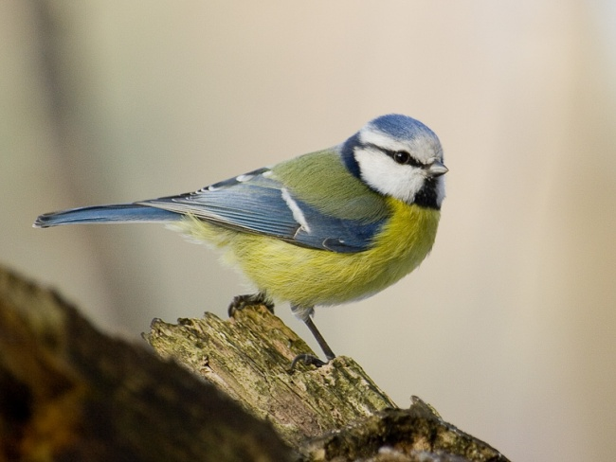

|  |  |  |  |  |  |  |
| --- | --- | --- | --- | --- | --- | --- |
| **S** | **Ý** | **K** | **O** | **R** | **K** | **A** |
|  |  |  |  |  |  |  |

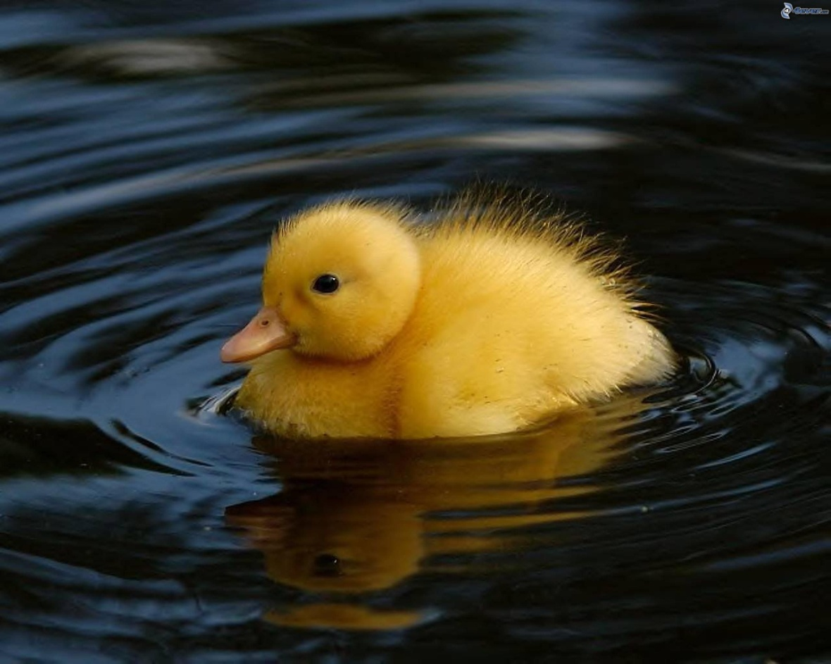

|  |  |  |  |  |  |  |
| --- | --- | --- | --- | --- | --- | --- |
| **K** | **Á** | **Č** | **A** | **T** | **K** | **O** |
|  |  |  |  |  |  |  |

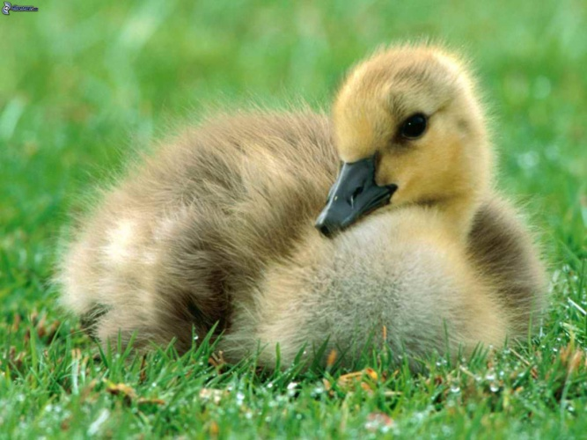

|  |  |  |  |  |  |  |
| --- | --- | --- | --- | --- | --- | --- |
| **H** | **Ú** | **S** | **A** | **T** | **K** | **O** |
|  |  |  |  |  |  |  |



|  |  |  |  |  |  |  |
| --- | --- | --- | --- | --- | --- | --- |
| **T** | **U** | **Č** | **N** | **I** | **A** | **K** |
|  |  |  |  |  |  |  |

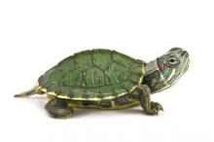

|  |  |  |  |  |  |  |  |  |  |
| --- | --- | --- | --- | --- | --- | --- | --- | --- | --- |
| **K** | **O** | **R** | **Y** | **T** | **N** | **A** | **Č** | **K** | **A** |
|  |  |  |  |  |  |  |  |  |  |

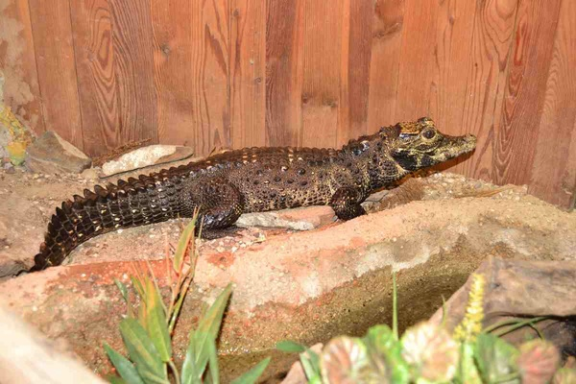

|  |  |  |  |  |  |  |  |
| --- | --- | --- | --- | --- | --- | --- | --- |
| **K** | **R** | **O** | **K** | **O** | **D** | **Í** | **L** |
|  |  |  |  |  |  |  |  |

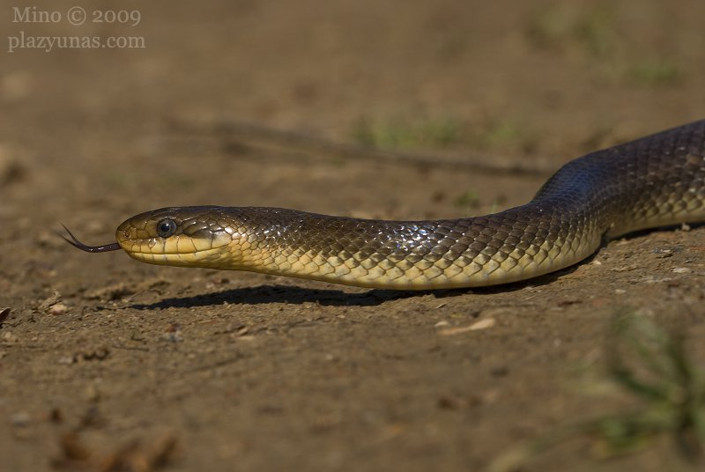

|  |  |  |
| --- | --- | --- |
| **H** | **A** | **D** |
|  |  |  |

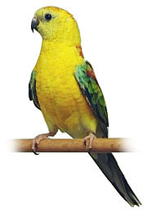

|  |  |  |  |  |  |  |
| --- | --- | --- | --- | --- | --- | --- |
| **P** | **A** | **P** | **A** | **G** | **Á** | **J** |
|  |  |  |  |  |  |  |



|  |  |  |  |  |
| --- | --- | --- | --- | --- |
| **L** | **A** | **B** | **U** | **Ť** |
|  |  |  |  |  |

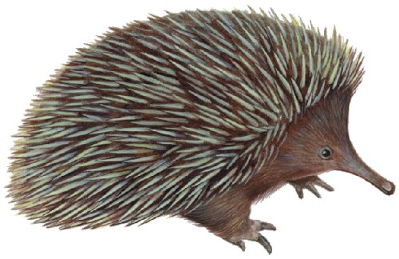

|  |  |  |  |  |  |
| --- | --- | --- | --- | --- | --- |
| **J** | **E** | **Ž** | **U** | **R** | **A** |
|  |  |  |  |  |  |

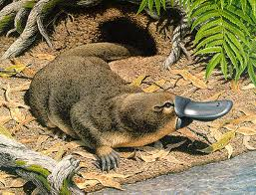

|  |  |  |  |  |  |  |  |  |
| --- | --- | --- | --- | --- | --- | --- | --- | --- |
| **V** | **T** | **Á** | **K** | **O** | **P** | **Y** | **S** | **K** |
|  |  |  |  |  |  |  |  |  |